PRODUCT REQUIREMENTS DOCUMENT

(PRD)

Explainable AI Candidate Ranking Framework for Applicant Tracking Systems (ATS)

Prepared as a Solution Proposal Role: Product / UX / AI Platform

Summary
This is not an ATS with AI added as a standalone feature. AI is embedded within the candidate evaluation workflow, enhancing resume parsing, candidate ranking, and decision support while keeping recruiters in control of the hiring process. This proposal introduces a dual-scoring candidate evaluation framework that combines Match Score and Confidence Score. The objective is to improve transparency, trust, explainability, and recruiter decision-making within AI-powered hiring platforms.

Problem Statement
Traditional ATS platforms rely heavily on a single ranking score. Recruiters often cannot determine whether a high score is supported by reliable evidence. This creates trust issues, false positives, and inconsistent hiring decisions.

Business Opportunity
By introducing AI explainability and confidence-based ranking, organizations can improve hiring quality, reduce recruiter screening effort, increase trust in AI recommendations, and create a more auditable recruitment process.

Product Vision
Enable recruiters and hiring managers to understand not only who is the best candidate, but also how confident the AI is in its recommendation.

Target Users
Primary Users: Recruiters, Talent Acquisition Teams, Hiring Managers. Secondary Users: HR Leadership, Compliance Teams, Interview Panels.

Proposed Solution
The ATS calculates two independent scores:

Match Score = Candidate-to-Job Fit
Confidence Score = Reliability of AI Assessment

The final ranking considers both scores before generating recommendations.

Match Score Framework
Inputs:
  - Skills Match

  - Experience Match
  - Education Match
  - Certifications
  - Industry Experience
  - Location Fit
  - Keyword Relevance

Output: Candidate Fit Percentage

Confidence Score Framework
The Confidence Score measures the reliability, completeness, and trustworthiness of the AI's assessment. It indicates how confident the system is that the candidate evaluation is based on verified evidence rather than assumptions or incomplete information.

Inputs:
- Resume Quality
- Parsing Accuracy
- Data Completeness
- Evidence Strength
- Consistency Checks
- Verification Signals
- OCR Quality
- Ambiguity Detection
- AI Inference Risk

Hallucination Prevention Layer
The system continuously detects situations where AI may generate inaccurate conclusions due to ambiguous, incomplete, or poorly structured data.

Examples:
  - Skills inferred without supporting project evidence
  - Experience duration assumptions
  - OCR extraction errors
  - Ambiguous job titles or responsibilities
  - Unverified certifications
  - Contradictory resume information

AI Resolution Mechanisms:

  - Evidence-based validation for every extracted skill and experience
  - Confidence reduction when supporting evidence is weak or missing
  - Ambiguity detection and verification checks
  - Risk flagging for inferred or unverified information
  - Explainable AI (xAI) insights showing verified vs. inferred data

Output:
  - AI Confidence Percentage
  - Hallucination Risk Indicator (Low / Medium / High)
  - Verification Status (Verified, Partially Verified, Inferred)
    - Final Candidate Rating =(Match Score × 50%)+(Confidence Score × 30%)-(Risk Score × 10%)-(Hallucination Risk × 10%)

This framework ensures recruiters can trust AI recommendations by providing transparency into data quality, evidence strength, and potential AI uncertainty before candidate ranking decisions are made.

AI Validation Engine
The system continuously evaluates potential risks such as parsing failures, missing dates, keyword stuffing, employment gaps, missing project evidence, certification gaps, and contradictory information.

Candidate Ranking Logic
High Match + High Confidence = Auto Rank
High Match + Medium Confidence = Rank with Warning High Match + Low Confidence = Manual Review
Low Match + High Confidence = Archive / Reject
A good enhancement is to make the ranking logic more intelligent by introducing Candidate Improvement Workflow, Recruiter Explainability Workflow, and AI Feedback Loop without removing any of your existing content.

10A. Enhanced Candidate Ranking Logic
The ranking engine evaluates both Match Score and Confidence Score before assigning candidate status.

Match Score Confidence Score Action

High | High | Auto Rank
High | Medium | Rank with Warning

Match Score Confidence Score Action

High | Low | Recruiter Review Required
Medium | High | Consider for Pipeline
Medium | Medium | AI -> Manual Screening
Medium | Low | Candidate Improvement Required
Low | High | Archive / Reject
Low | Medium | Archive with Feedback
Low | Low | Reject

10B. AI Candidate Improvement Workflow
When a candidate achieves a strong Match Score but receives a low or medium Confidence Score, the system automatically initiates a Candidate Improvement Process.

Examples
Candidate Match Score = 88% Confidence Score = 52%
The AI identifies missing evidence:
- Missing employment dates
- Missing project descriptions
- Unverified certifications
- Skills listed without supporting experience
- Incomplete contact information
- Resume formatting issues
- OCR extraction issues

AI Action
System sends an automated email:
Your profile demonstrates strong relevance for the role. However, certain information could not be validated by our AI screening process. Please update the highlighted sections and resubmit your profile for reconsideration.

10C. Candidate Feedback Categories

Missing Information
- Employment Dates Missing
- Education Details Missing
- Certification Expiry Missing
- Location Missing

Evidence Gaps
- Skill Mentioned Without Project Evidence
- Technology Mentioned Without Experience Duration
- Leadership Claims Without Supporting Examples

Resume Quality Issues
- Poor Formatting
- Low OCR Readability
- Image-Based Resume
- Unsupported File Structure
Consistency Issues
- Conflicting Job Titles
- Overlapping Employment Dates
- Experience Mismatch
- Certification Mismatch

10D. Automated Candidate Notification Engine Scenario 1: High Match + Low Confidence
Status:
Recruiter Review Pending Candidate receives:
Your application is highly relevant to the position. However, additional information is required before further evaluation. Please update the highlighted sections of your profile.

Scenario 2: Rejected Due to Low Match Score
Status:
Rejected
Candidate receives:
Thank you for your interest. Based on our current evaluation, your profile does not meet the minimum requirements for this role. We encourage you to update your profile and apply for

future opportunities. Your resume will remain in our talent database for upcoming opportunities.

Scenario 3: Missing Information Detected
Status:
Action Required Candidate receives:
Additional information is required to complete your evaluation. Please review and update the following sections:
- Employment History
- Project Experience
- Certifications
- Skills Validation

10E. Explainable AI Risk Scoring
Alongside Match Score and Confidence Score, the system calculates a Risk Score.

Risk Indicators
🔴 High Risk
- Parsing Failure
- Significant Missing Information
- Multiple Contradictions
🟡 Medium Risk
- Partial Evidence
- Incomplete Certifications

- Limited Project Details Low Risk
- Fully Verifiable Profile
- Strong Supporting Evidence
- Consistent Information

Formula
Final Candidate Rating = (Match Score × 50%) + (Confidence Score × 30%) - (Risk Score × 20%)

10F. Recruiter Decision Support Panel
Recruiters see:

Candidate Summary
Match Score: 89%
Confidence Score: 72% Risk Score: Medium

AI Findings
- ✓ Skills Verified
- ✓ Experience Verified
- ⚠ Certification Not Verified
- ⚠ Employment Gap Detected
- ⚠ Project Evidence Missing

Recommendation
Rank Candidate #4
Manual Verification Recommended

10G. Candidate Reprocessing Workflow

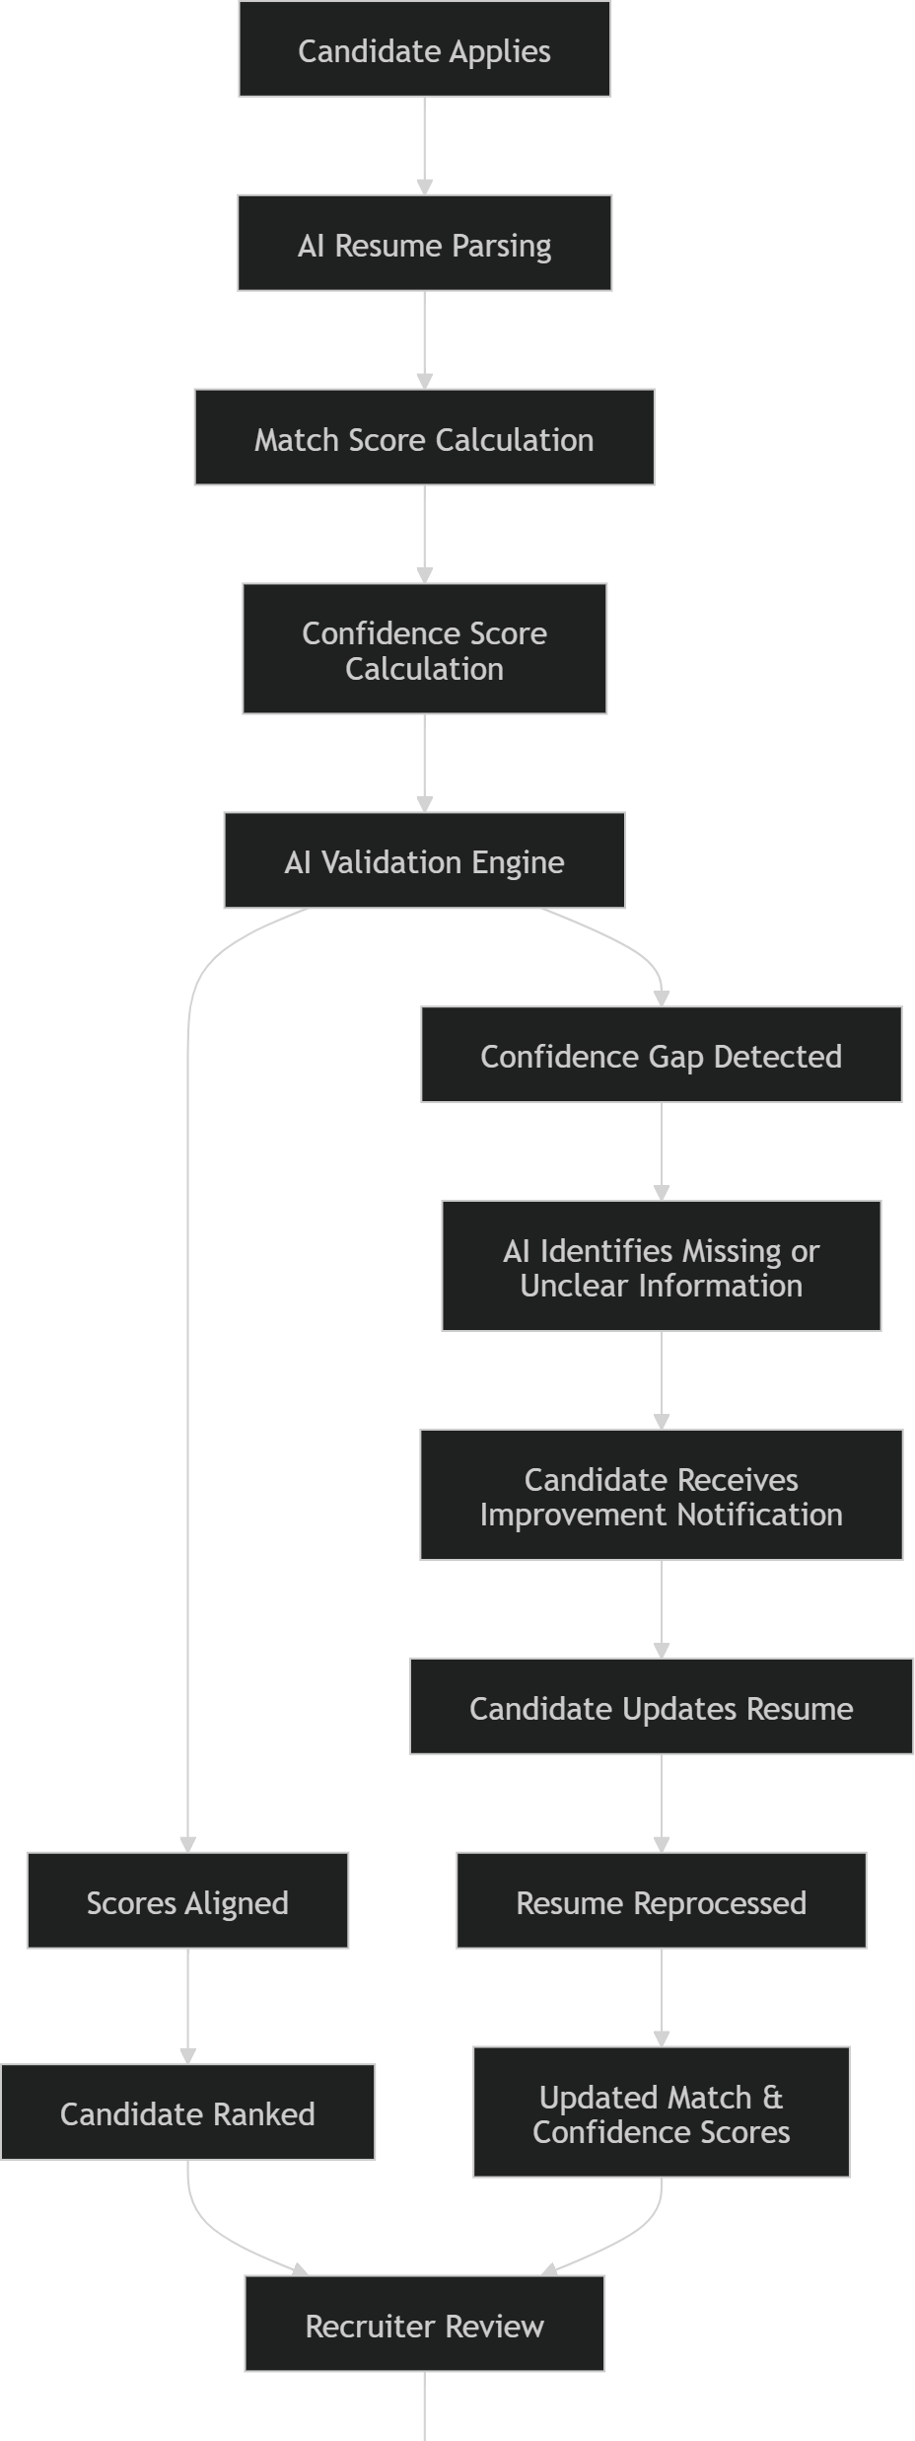

10H. ATS Talent Nurture Workflow
Instead of immediately rejecting all low-confidence candidates:

Talent Pool Categories
- Future Match Candidates
- Skill Gap Candidates
- Certification Gap Candidates
- Experience Gap Candidates
- High Potential Candidates

The AI can periodically invite these candidates to:
- Update their resumes
- Complete missing information
- Upload certifications
- Apply for better-matched jobs
These converts rejected applicants into a reusable talent pipeline and significantly improves candidate experience while maintaining recruiter trust in AI recommendations.

Recruiter Dashboard Experience
Dashboard Components:
  - Match Score
  - Confidence Score
  - Risk Indicators
  - Missing Information Alerts
  - AI Recommendations
  - Explainability Panel
  - Candidate Comparison View

Explainability Layer
Every score should provide supporting evidence. Recruiters must understand why a score was assigned and what factors reduced confidence.

Sample AI Warnings
⚠ Missing experience dates.
⚠ Skill match detected but project evidence unavailable.
⚠ Employment history contains gaps.
⚠ Resume parsing confidence is low.
⚠ Certifications could not be verified.

User Journey
Job Created → AI JD Generation → Applications Received → Resume Parsing → Match Score → Confidence Score → Validation Engine → Ranking → Recruiter Review →Freezing → Interview → Hiring

Success Metrics (KPIs)
  - Shortlist Accuracy
  - Recruiter Acceptance Rate
  - Time-to-Shortlist
  - False Positive Reduction
  - Recruiter Trust Score
  - Hiring Quality Improvement

Future Roadmap
  - LinkedIn Validation
  - Certification Verification APIs
  - Interview Performance Correlation
  - Predictive Success Models
  - AI-Powered Candidate Coaching

Expected Business Impact
The framework improves transparency, reduces hiring risk, strengthens compliance, enhances recruiter productivity, and builds trust in AI-driven hiring decisions.

ATS Decision Matrix

Match Score | Confidence Score | Action
High | High | Auto Rank
High | Medium | Rank with Warning
High | Low | Recruiter Review
Low | High | Reject / Archive

